Philadelphia University
Faculty of Information Technology
Department of Software Engineering
Examination Paper
Lecturers Dr. Mohammad Taye
Coordinator Dr. Mohammad Taye
Internal Examiner: Dr.M. AL-Athami

Course Name: GUI (721423) Section: 1 First Exam

Information for Candidates
- This examination paper contains questions 5totaling 20 marks.
- The marks for parts of questions are shown in round brackets.

Advice to Candidates
1. You should attempt all questions
2. You should write your answers precisely, clearly and to the point.

I. Basic Notions
Objectives. The aim of the question in this part is to evaluate the required minimal student knowledge and skills. Answers in the pass category represent the minimum acceptable standard.

Question 1 (2 marks)
What are the Benefits of usability? 2 marks

Question 2 (5 marks)
Can we use the Traditional systems development for desinging user interface? 1 mark
Explain how is the user interface designed? 2 marks

II. Familiar Problems Solving
Objectives. The aim of the question in this part is to evaluate that the student has some basic knowledge of the key aspects of the lecture material and can attempt to solve familiar problems.

Question 4 (4 marks)
Based on Usability problems classification, classify the following problems?
      - Cannot figure out how to start using service. Finally, found a support system is helping.
- Believes he has registered in C # course, but forgot to push Save.
- New social networking website has 12 screens to fill in 15 fields.
- Wants to show Timetable for Lecture Tutorial, but the system cannot do it.
- What are critical usability problems?

Question 4 (6 marks)
You have the following screens of “finished ATM system” you are looking forward to show the performance of the system

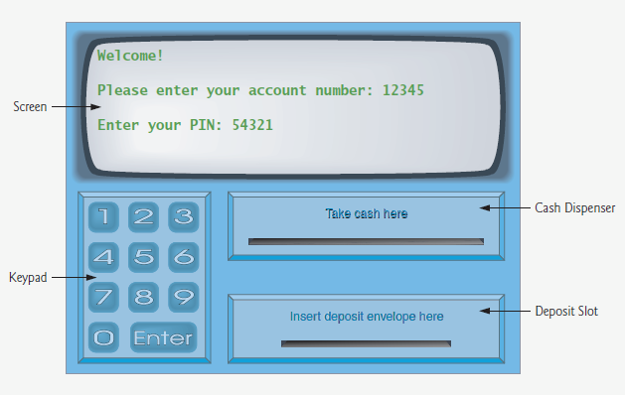 | 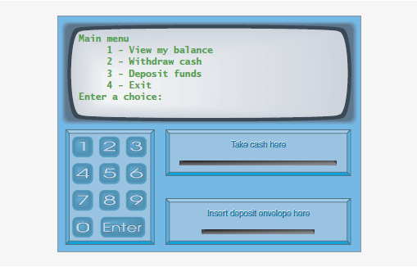
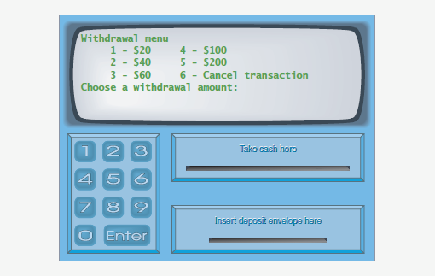

What measure you will use? 1 mark

Why you choose that measure? 2 marks
Classic approach
Good when buying
Not possible early

Apply the measure. 4 marks

III. Unfamiliar Problems Solving
Objectives. The aim of the question in this part is to evaluate that the student has some basic knowledge of the key aspects of the lecture material and can attempt to solve unfamiliar problems.

Question 5 (3 marks)
Philadelphia University intends to build new system for all their work, and asked you to give your suggestion about designing Interactive User Interfaces how you could help.

Question 1 (2 marks)
What are the Human factors that should be taken in your account when you design User -Interface?
- Limited short-term memory
  - People can instantaneously remember about 7 items of information. If you present more than this, they are more liable to make mistakes.
- People make mistakes
  - When people make mistakes and systems go wrong, inappropriate alarms and messages can increase stress and hence the likelihood of more mistakes.
- People are different
  - People have a wide range of physical capabilities. Designers should not just design for their own capabilities.
- People have different interaction preferences
  - Some like pictures, some like text.

Question 2 (3 marks)

- Describe how is the user interface designed in iterative design? What are the Weakness points to this approach? [3 marks]

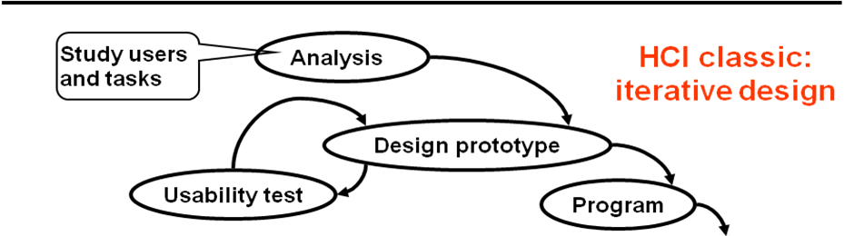

- Three core techniques
  - Let developer study the users and their tasks as part of task analysis
  - Make a prototype early and review it with users
  - Usability test the prototype with users, correct and test again for iterative design

- Weak points to this approach
  - There is no systematic way to design the screens
  - There is no systematic way to correct usability problems once they are detected.
  - There is no systematic way to find test users with the right profile.

Question 2 (3 marks)
- What are the purposes for prototypes? [2]
- What are the benefits of usability?[2]
  - Usability testing and finding usability problems
  - Changing the design
  - Defining what to program
  - Discussing solutions with users

- Benefits of usability
  - Faster learning
  - Faster daily work
  - Fewer errors
  - Less demand for hot-line
  - Better motivation and less stress
  - More users
  - Wider work areas (generalization of skills)
  - Let the customer do the work (e-commerce)
- The cost of usability (it pays for itself)

II. Familiar Problems Solving
Objectives. The aim of the question in this part is to evaluate that the student has some basic knowledge of the key aspects of the lecture material and can attempt to solve familiar problems.

Question 3 (4 marks)

Based on Usability problems classification, describe the following problems?
Missing functionality – the system cannot support the user’s task.
Annoying – the user complains that the system is awkward.
Minor – the user succeeds after a few attempts.
What is Critical problem (the critical usability problems)?
Missing functionality, task failure, or annoying to users

Question 4 (5 marks)

You have been asked to test the Bus Ticketing Systems, describe what types of measurements of usability will you use and why?
Provide a test plan ? [5marks]
  - Task time
  - Problem counts
  - Keystroke counts
  - Opinion poll
  - Score for understanding
Guideline adherence

Describe how uou could
Planning the test

Choose test users
Typical users for the system.
Don’t select other developers (unless it is an application to be used by developers).
Choose test tasks
Real work situation – select some realistic scenarios for the user to perform.
Closed – preferably, a task should accomplish something useful – a complete function of the application.
Without hidden help – without hints on how to carry out the task.
If you are not familiar with the system, then you must also study the system yourself.
Explain the purpose clearly to the user.
It is the system that is being tested, not the user.
Assign the task
Remind user to think aloud by explaining what he does and why
Observe and record the user’s actions and words.
Offer help when user asks for it.
As much as possible, leave user alone to struggle with the task.
Condense the issues found into a list of problems.
This should be done as early as possible, within 12 hours, while your memory is fresh.

III. Unfamiliar Problems Solving
Objectives. The aim of the question in this part is to evaluate that the student has some basic knowledge of the key aspects of the lecture material and can attempt to solve unfamiliar problems.

Question 6 (3 marks)

Draw full contents of a mockup that allow to user to create an account in mail system.
l Empty screens for copying
l Screens with realistic data
l Screens to be filled in by user
l Menus, lists, dialog boxes
l Error messages
l Help texts
l Notes about what functions do

Question 2 (2 marks)
What are quality factors & usability factors?

II. Familiar Problems Solving
Objectives. The aim of the question in this part is to evaluate that the student has some basic knowledge of the key aspects of the lecture material and can attempt to solve familiar problems.

Question 3 (4 marks)
Based on you studying of the measurements of usability answer the following questions:

- Which of them are good when you buy a finished system? [1 mark]

- Which of them are good when you are developing a new system? [1 mark]

- In your opinion, which one is the best, and why? [2 marks]

Question 4 (5 marks)
Based on Usability problems classification, describe the following problems?
The system works as intended by the programmer, but the user:
1. Cannot figure out how to start using service. Finally, found a support system is helping.
2. Believes he has registered in C # course, but forgot to push Save. Task failure (P2, P3)
3. New social networking website has 12 screens to fill in 15 fields. Annoying (P4)
4. Wants to show time table of courses, but the system cannot do it. Missing functionality (P5)

5. What is Critical problem (the critical usability problems)?
Missing functionality, task failure, or annoying to users

Question 5 (3 marks)
How you could make a good User Interface design?

III. Unfamiliar Problems Solving
Objectives. The aim of the question in this part is to evaluate that the student has some basic knowledge of the key aspects of the lecture material and can attempt to solve unfamiliar problems.

Question 6 (4 marks)
You have been asked to design a form for collecting student feedback on individual taught courses through the World-Wide Web. Consider what design options are available for form-filling.

- State how you would apply them in good prototype?
- What are the purposes for prototypes?

  - Usability testing and finding usability problems
  - Changing the design
  - Defining what to program
Discussing solutions with users
- Usability test of the prototype
  - Test tasks
  - Test users
- Heuristic evaluation results
  - Other designers look at the user interface and identify the potential usability problems
- The defect list
- Improving the prototype

Full contents of a mockup
l Empty screens for copying
l Screens with realistic data
l Screens to be filled in by user
l Menus, lists, dialog boxes
l Error messages
l Help texts
l Notes about what functions do

- Parts of a usability test
  - Think-aloud test
  - Can use a real system
  - Can use prototypes and mock-ups of the system
  - Test team with facilitator, log-keeper, and observer
- Steps of a usability test
  - Plan the test
  - Carry out the test
  - Report the results
- Plan
- Test-users:
- Test-tasks:
- Study system yourself
- Carry out
- Explain purpose:
- - Find problems when using the system
- - System’s fault - not yours
- Give task - think aloud, please
- Observe, listen, note down
- Ask cautiously:
- - what are you looking for?
- - why . . . ?
- Help users out when they are surely lost
- Reporting
- List the usability problems - within 12 hours

- What is a Graphical User Interface ?
- A graphical user interface (GUI) is a human-computer interface (i.e., a way for humans to interact with computers) that uses windows, icons and menus and which can be manipulated by a mouse (and often to a limited extent by a keyboard as well).

- Three core techniques
  - Let developer study the users and their tasks as part of task analysis
  - Make a prototype early and review it with users
  - Usability test the prototype with users, correct and test again for iterative design
- Weak points to this approach
  - There is no systematic way to design the screens
  - There is no systematic way to correct usability problems once they are detected.
  - There is no systematic way to find test users with the right profile.

- The purposes for prototypes
  - Usability testing and finding usability problems
  - Changing the design
  - Defining what to program
  - Discussing solutions with users

